Stakeholders products:

- Microservices Platform - use existing and personalize - open source
- CNP (Cloud Native Platform) - a development framework capable to build Cloud Native Application and Platform Integration pipelines (CI/CD, Platform Management and Monitoring, Automate scaling strategies) - open source - IntelliJIDEA
- Spot - a persistence system for IoT and Big Data - open source
- VRAF - a business hub hosting for Cloud Native Application and Cooperative Development Program - commercial SLA
- SBA (Stakeholders Business Application) - The services and application as product of the stakeholders investments in VRAF or private VRAF - commercial SLA
- CES (Cooperative Engineering Services) - A specialized engineering consultancy and services program for external business - commercial
- Electronic IoT devices - custom IoT and Cloud Native compliant devices for end-user service integration (i.e. - a uniform interface for cash register, etc) - commercial
- EDEN (Enunciations, Demonstrations, Errors, Natural) - Science Uniformed Indexed Space and Smart Advisor - free-content, SLA
- Body - an uniformed platform development for GUI - open source - Vaadin
- DNA (Development Natural Application) - CNAD with NLP (Natural Language Programming) - research, shared ?? - JetBrains
- GOD (Graphical Object Device) - “abstract” device capable to present Media Application (smartphone, mobile device) - commercial

What is the idea:

The idea is to put a brick to Towered the Bable, in spite of the awareness of the myth we are far from a consensual reality of the natural cooperative behavior. The need of expansion of individual entities has grown as planetary level and terms as Globalization are promoted. This expansion has proved to be in benefit of all and as we gain in means and tools, we’ve started to realise the power of the group. From the natural science and mathematics means of uniformization of the language and behavioural aspect of the problem, the business sector has also seen the advantage of uniformization. In this matter international organizations are making efforts to standardise. The gap between natural science and business industries has low diffusion. As with all this matters the willing of cooperative interactions is bound in means and tools, this represent a lack of Applied Science Institutes and indexing tools. A lot of human research and studies has been lost over the past decades in order to be applied. Other parallel research wasted time in order to implement same matters.
In these humanity days, matters like time to market, service quality, process optimizations, partnerships, customer care are the key assets in order to maximize the shareholder value of a business. On the other hand, in order to internally sustain a Research & Development process for innovations in a continuous changing industry like software development is likely a bad strategy or at least one with lots of risks.
To cover the main aspects and to put it into the business strategy this can be implemented as Communities as Cooperative associations. The model is figured in the Venn diagram below.
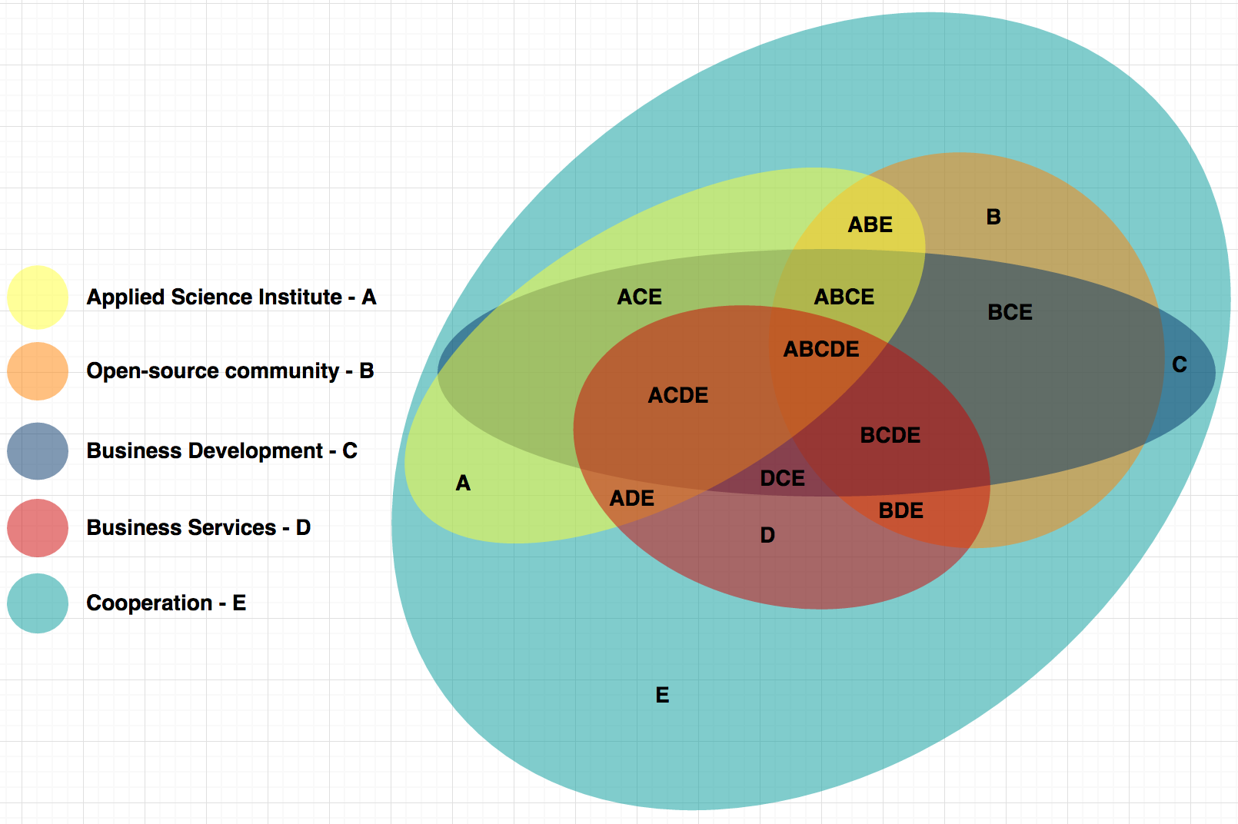
A - Cooperative of the Applied Science Institute
B - Cooperative of the Open-source community
C - Cooperative of the Business Development
D - Cooperative of the Business Services
E - Cooperation among cooperatives
ABE - Cooperation among Applied Science Institute and Open-source community
ACE - Cooperation among Applied Science Institute and Business Development
ADE - Cooperation among Applied Science Institute and Business Services
ABCE - Cooperation among Applied Science Institute and Open-source community and Business Development
ACDE - Cooperation among Applied Science Institute and Open-source community and Business Services
ABCDE - Cooperation among Applied Science Institute and Open-source community and Business Development and Business Services
BCE - Cooperation among Open-source community and Business Development
BDE - Cooperation among Open-source community and Business Services
BCDE - Cooperation among Open-source community and Business Development and Business Services
DCE - Cooperation among Business Development and Business Services

Cooperatives roles:

Applied Science Institute - research of the natural science behind the Information Technology and current applied of the field in order to patterns recognize or demonstration as common use and standardization. (i.e. The need of a real extension of the WWW for Media Application as Services to maximize the cloud computing and cloud development as a Hyperspace Uniform Media Application Named).

Open-source community - keep awareness and quality of the development

Business Development - business analysis and track for opportunities

Business Services - market and sales the commercial assets

Cooperation among cooperatives - the orchestra of the hole picture

Stakeholder benefits:

Beside the business in the cooperation among cooperatives other business could be developed as separate part of the cooperatives: such as hub hosting solution, human resources provider other stakeholders business based on the open-source components and custom business process development.

Other benefits could be gain by standardization processes (i.e. beside Information Technology, others standardization could be developed such as lifestyle in cooperative environments)

